

Topic test 1
Name: __________________________________

Chapter 1: Three-dimensional vectors

- Time allowed: 45 minutes
- CAS calculators may be used.
- Part A: 5 multiple-choice questions (5 marks).
- Part B: 6 short-answer questions (44 marks).
- Part C: 2 analysis questions (11 marks).
Part A
Multiple-choice questions
5 multiple-choice questions
1 mark each: 5 marks
Circle the correct answer.
1 Q(2, −3, −5) and which of the following points are on a line parallel with the z-axis?
A (−2, 3, −5)
B (2, 3, −5)
C (2, −3, 6)
D (4, −2, −5)
E (5, −2, −3)
[1 mark]
2 The distance between P(a, b, c) and Q(d, b, c) is:
A |a − b|
B |c − a|
C |b − c|
D |a − d|
E |a − c|
[1 mark]

Use the diagram below to answer Questions 3–5.

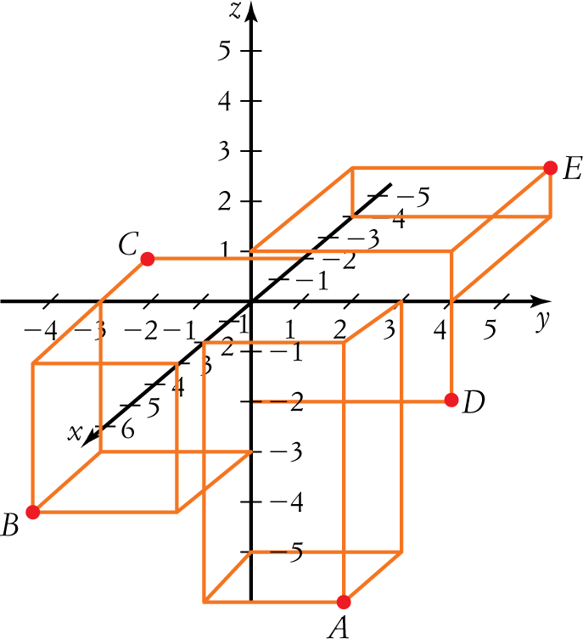
3 The point lying on the yz-plane is:
A A
B B
C C
D D
E E
[1 mark]
4 The point C is best described as lying on the:
A yz-plane
B y-plane
C xz-plane
D x-plane
E xy-plane
[1 mark]
5 The points lying on a plane parallel to the xz-plane are:
A E and C
B A and D
C B and D
D B and C
E A and E
[1 mark]

Part B
Short-answer questions
6 short-answer questions
44 marks
Show your working where appropriate.
1 Find the radius and centre of the sphere
x2 + y2 + z2 − 4x + 8y − 6z − 20 = 0
[6 marks]
2 Given m = (−1, 3, 4), n = (5, −2, 6), and A = (4, 3, −7) and B = (−3, −1, 4):
a find −3m + 4n
b show that (m − n) is parallel to (n − m)
c find AB and |AB|
d find 
[10 marks]
3 a Show that the vectors (−1, −3, 4) and (6, 2, 3) are perpendicular.
b Find the projection of m = (−2, 1, −5) on n = (1, −3, 4).
c Find the angle between p = 2i + 5j − 3k and q = i − 4j − 3k.
[10 marks]
4 a Find the vector product of vectors of magnitudes 15 and 9 if the angle between them is 75°.
b Find the vector product of u = (3, −1, 5) and v = (−4, 2, −3).
[7 marks]
5 a Find the Cartesian form of the equation of the straight line which passes through the points
(2, 5,−3) and (1, 3,−6).
b Calculate the equivalent vector equation for the line.
[6 marks]
6 Find the equation of the plane that contains the points P(3, −1, 4), Q(6, 2, 5) and R(−2, 1, 3).
[5 marks]

Part C
Analysis questions
2 analysis questions
11 marks
Show your working where appropriate.
1 Prove the parallelogram law which states:
The sum of the squares of lengths of both diagonals of a parallelogram is equal to the sum of the squares of the lengths of all four sides.
[7 marks]
2 Find the equation of the plane that is equidistant from the points A(3, 2, 1) and B(−3, −2, −1) (that is, every point on the plane has the same distance from the two given points).
[4 marks]
[Total marks: 60]

Answers
Part A – Multiple-choice questions [1 mark each]
1 Points on a line parallel to the z-axis will have x- and y-coordinates the same but different z-coordinates.
 C [1 mark]
2 P and Q have different x-coordinates but the y- and z-coordinates are the same.
The points are on a line parallel to the x-axis.
The distance between P and Q will be the absolute value of the difference between the x-coordinates
i.e. |a − d|
D [1 mark]
3 Any point on the yz-plane will have an x-coordinate of 0.
D = (0, 4, 0).
 D [1 mark]
4 C = (−2, −3, 0).
The z-coordinate is 0, C lies on the xy-plane.
 E [1 mark]
5 Any points lying on a plane parallel to the xz-plane will have the same y-coordinate.
B = (4, −3, −3) and C = (−2, −3, 0)
 D [1 mark]
Part B – Short-answer questions
1 x2 + y2 + z2 − 4x + 8y − 6z − 20 = 0
x2 + y2 + z2 − 4x + 8y − 6z = 20
(x2 − 4x) + (y2 + 8y) + (z2 − 6z) = 20 [1 mark]
(x2 − 4x + 4) + (y2 + 8y +16) + (z2 − 6z + 9) = 4 + 16 + 9 + 20 [1 mark]
Factorise the squares. (x − 2)2 + (y + 4)2 + (z − 3)2 = 49 [1 mark]
(x − 2)2 + (y + 4)2 + (z − 3)2 = 72 [1 mark]
Compare with (x − h)2 + (y − k)2 + (z − l)2 = r2
Centre = (2, −4, 3) [1 mark]
Radius = 7 [1 mark]
[6 marks altogether]
2 a −3m + 4n = −3(−1, 3, 4) + 4(5, −2, 6) [1 mark]
= (3, −9, −12) + (20, −8, 24)
= (23, −17, 12) [1 mark]
b m − n = (−1, 3, 4) − (5, −2, 6)
= (−6, 5, −2) [1 mark]
n − m = (5, −2, 6) − (−1, 3, 4)
= (6, −5, 2)
= −1(−6, 5, −2) [1 mark]
= −1(m − n)
Thus (m − n) is parallel to (n − m) [1 mark]
c AB = (x2 − x1, y2 − y1, z2 − z1)
= (−3 − 4, −1 − 3, 4 + 7)
= (−7, −4, 11) [1 mark]
|AB| = 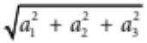
= 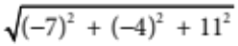
= 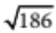 [1 mark]
d = 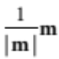 [1 mark]
= 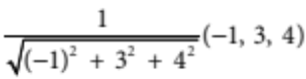 [1 mark]
= 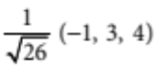
= 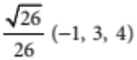 [1 mark]
[10 marks altogether]
3 a (−1, −3, 4) . (6, 2, 3) = −6 − 6 + 12
= 0 [1 mark]
Since the scalar product is zero and the vectors are not zero vectors, the vectors are perpendicular. [1 mark]
b pn m = m . [1 mark]
= 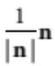
= 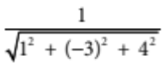(1, −3, 4)
= 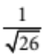 (1, −3, 4) [1 mark]
pn m = (−2, 1, −5) . (1, −3, 4)
= (−2 − 3 − 20) [1 mark]
= 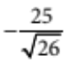  −4.9 [1 mark]
c cos(θ) = 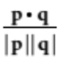 [1 mark]
= 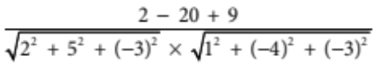 [1 mark]
= 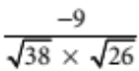
= 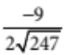 [1 mark]
θ  106.6° [1 mark]
[10 marks altogether]
4 a |v| = |v1| |v2| sin(θ) [1 mark]
= 15 × 9 × sin(75°) [1 mark]
 130.4 [1 mark]
The vector product is about 130 in a direction perpendicular to the plane of the original vectors. [1 mark]
b u = 3i − j + 5k, v = −4i + 2j − 3k [1 mark]
u × v = (−1 × −3 − 5 × 2)i − (3 × −3 − 5 × −4)j + (3 × 2 − −1 × −4)k [1 mark]
= −7i − 11j + 2k
= (−7, −11, 2) [1 mark]
[7 marks altogether]
5 a Let A(a1, a2, a3) = (2, 5,−3)
and B(b1, b2, b3) = (1, 3,−6) [1 mark]
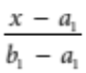= 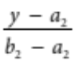 = 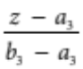
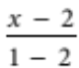 = 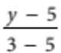 = 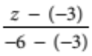 [1 mark]
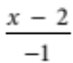 = 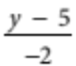 = 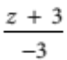 [1 mark]
b Compare = = with 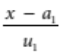 = 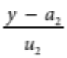 = 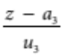
a1 = 2, a2 = 5, a3 = −3
and u1 = −1, u2 = −2, u3 = −3 [1 mark]
p = a + tu
= a1i + a2j + a3k+ t(u1i + u2j + u3k) [1 mark]
p = 2i + 5j − 3k + t(−i − 2j − 3k) [1 mark]
[6 marks altogether]
6 PR = (2 − 3, 1 − (−1), 3 − 4) = (−5, 2, −1)
PQ = (6 − 3, 2 − (−1), 5 − 4) = (3, 3, 1) [1 mark]
PR × PQ is normal to the plane containing PR and PQ [1 mark]
PR × PQ = (2 × 1 − (−1) × 3)i − (−5 × 1 − (−1) × 3)j + (−5 × 3 − 2 × 3)k
= 5i + 2j − 21k = n [1 mark]
Cartesian equation of the plane is: a1(x − x1) + a2(y − y1) + a3(z − z1) = 0
Let P(3, −1, 4), and n = (5, 2, −21) [1 mark]
5(x − 3) + 2(y + 1) − 21(z − 4) = 0
5x − 15 + 2y + 2 − 21z + 84 = 0
5x + 2y − 21z + 71 = 0 is the equation of the plane [1 mark]
[5 marks altogether]
Part C – Analysis questions
1 Draw a sketch.
Label the vertices O, A, B and C.
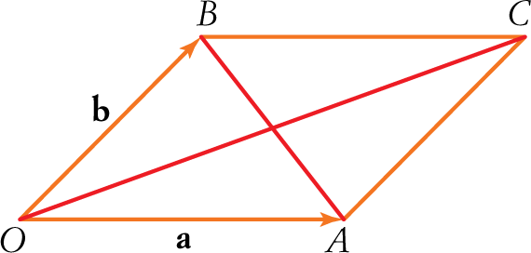
[1 mark]
OA = a
OB = b
OC = a + b
AB = a − b [1 mark]
|a|2 = a . a
|b|2 = b . b [1 mark]
|a + b|2 = (a + b) . (a + b)
|a − b|2 = (a − b) . (a − b) [1 mark]
The squares of the lengths of the diagonals
= |a + b|2 + |a − b|2
= (a + b) . (a + b) + (a − b) . (a − b)
= [a . a + 2(a . b) + b . b] + [a . a − 2(a . b) + b . b]
= 2(a . a) + 2(b . b)
= 2|a|2 + 2|b|2 [1 mark]

The squares of the lengths of the four sides
= |a|2 + |a|2 + |b|2 + |b|2
= 2|a|2 + 2|b|2 [1 mark]
= The squares of the lengths of the diagonals [1 mark]
QED
[7 marks altogether]
2 The midpoint of the points A and B is the point
C = 0.5[(3, 2, 1) + (−3, −2, −1)] = (0, 0, 0) [1 mark]
A normal vector to the plane is given by
AB = (3, 2, 1) − (−3, −2, −1) = (6, 4, 2) [1 mark]
So, the equation of the plane is 6(x − 0) + 4(y − 0) + 2(z − 0) = 0 [1 mark]
3x + 2y + z = 0 [1 mark]
[4 marks altogether]
opic test 1

